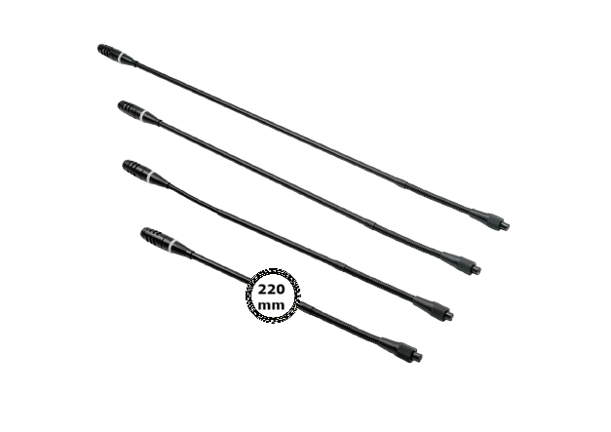
DCS-M220
Pluggable Gooseneck Microphone 220M

FEATURE

- Precise directional microphone head with Mini design.
- Two color LED ring indicator.
- Anti-wind microphone foam cover.
- Strong audio collection ability to work with different length of microphone.

FUNCTIONS

- Two-color LED indicator on microphone, red for speaking, green means need acceptance from chairman to speak.
- Screw lock socket to connect removable microphone.

ITEM MODEL FOR ORDER

DCS-M220..................220mm Microphone, with anti-wind foam cover
DCS-M410..................410mm Microphone, with anti-wind foam cover
DCS-M485..................485mm Microphone, with anti-wind foam cover
DCS-M600..................600mm Microphone, with anti-wind foam cover

TECHNICAL PARAMETERS

ITEM | DCS-M600 | DCS-M485 | DCS-M410 |  | DCS-M220
Directivity | Cardioid
Sensitivity | -46dBV/Pa
Frequency response | 30Hz~20KHz
Equivalent noise | 20dBA (SPL)
The maximum sound pressure | 125dB at 1KHz 1% T.H.D
Weight | 80g | 80g | 60g | 60g
Length | 600mm | 485mm | 410mm | 220mm
Color | black

About DAEWOO

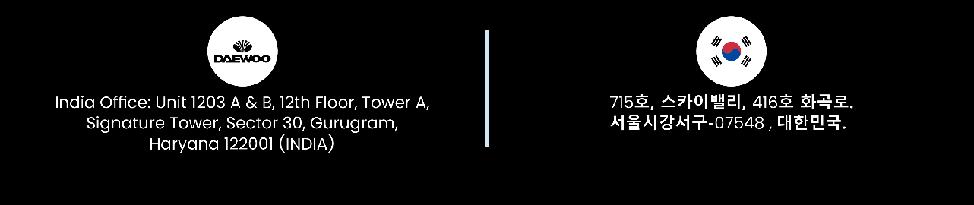
Our mission is to design and manufacture the most advanced and comprehensive audiovisual products for our clients. We strive to deliver the best performance-to-price ratio, ensuring satisfaction from the very first use. We believe that a combination of innovative design and cutting-edge technology adds value to our partners and end users. We listen to your needs and deliver solutions that fulfill them.

